**Tribhuvan University**

**Damak Multiple Campus**

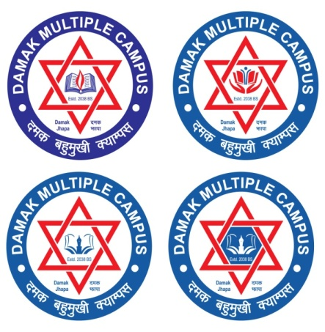**Faculty of Humanities and Social Science**

**A Lab Report of Operating System(CACS251)**

**Submitted By:**

**Nishma Gurung**

**Roll No: 26**

**BCA 4th Semester**

**Damak Multiple Campus**

**Submitted To:**

**Damak Multiple Campus BCA Programme Office**

**Faculty of Humanities and Social Science**

**Tribhuvan University**

**A Lab Report in partial fulfillment of the requirement for the degree of**

**Bachelor in Computer Application (BCA)**

**Jhapa, Nepal**

**May, 2021**

**Acknowledgement**

The lab work report has been prepared in the partial fulfillment of course “**Operating System**” of fourth semester of Bachelor of art in computer application while preparing this report, I got a lot of co-operation and suggestion from different persons.

I am thankful to **Mr.Abinash Jha** (subject teacher) for properly guiding me. I also want to thank my friends who helps me a lot in the lab work.

I would like to express my hearty thanks to my family member who provided inspiration and motivation regularly for my success.

Sandip chapagain

Roll No:

TU Registration No: 6-2-0202-0885-2019

**CERTIFICATE**

This is to certify that **Mr.Sandip chapagain** has successful completed the lab work required for the partial fullfillment of the “**Operating System**” under the guidance of subject teacher **Mr.Abinash jha.**

Subject Teacher:

Signature:

Date: